

KG Customer Database Management

USER MANUAL

**Prepared by: IT Department, Krishibid Group**

Content

1. Dashboard 2

**1.1 ERP Login Page** 2

**1.2 ERP Home Page** 3

2. Company’s Customer Management (KPL Packaging) 3

**2.1 Settings** 3

**2.1.1 Customer List** 3

**2.1.2 Customer Entry Page** 4

# 1. Dashboard

## **1.1 ERP Login Page**

Open the browser and type the following address: <http://103.132.94.84:90> then a page similar to the one shown in the image below will be displayed whereby a user will be required to type in their correct **username** and **password**. This system works best with Google Chrome, Mozilla Firefox, Microsoft Edge or Opera browsers. From here on, the use of the word “browser” will refer to above mentioned web browsers only.

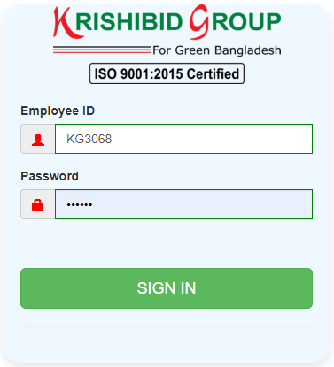

**Figure: 01 ERP Login**

**Logging on ERP System:**

* **Step-1:** Provide Valid **Username and Password. For Username Always Provide your Employee ID. (Example: EmployeeId: KGXXXX, Password: KGXXXX) with UPPERCASE.**
* **Step-2:** Click on **‘Sign In’** button for go to Home page of ERP.

## **1.2 ERP Home Page**

On successful login, a user is directed to the Home Page which consists of the main menu on the left side named dashboard. At the top most part of the system you will have on your left a home icon to denote the home page, a help button- which contains this help manual and the Employee Id of the user currently accessing the system.

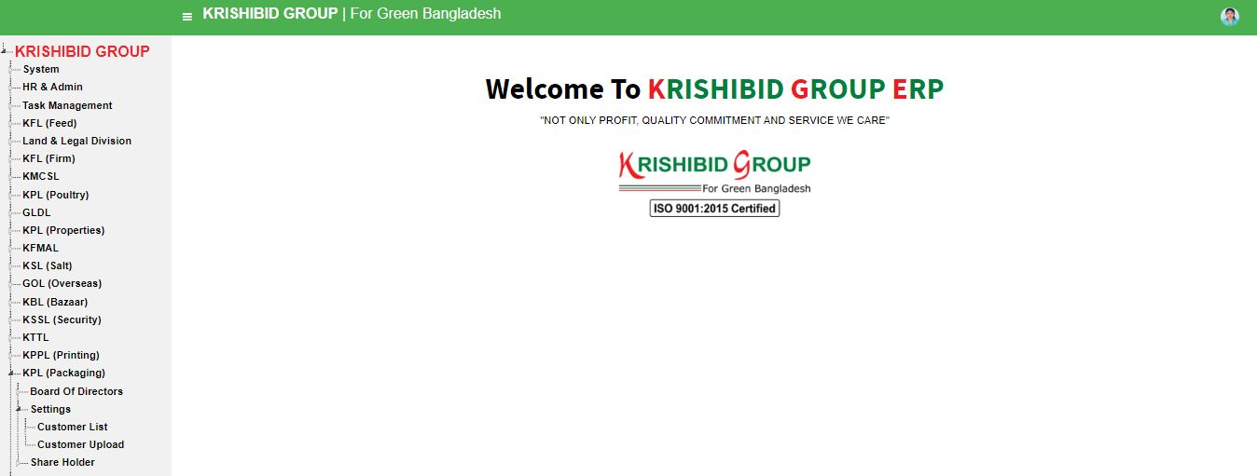The following figure (Fig-02) shows menu bar and home page.

**Figure: 02 ERP Home Page**

* **Step-01:** Click on the Dashboard section under main navigation panel of KG ERP.

# 2. Company’s Customer Management (KPL Packaging)

## **2.1 Settings**

### 2.1.1 Customer List

**Figure: 03 Customer List**

* **Step-01:** Click on the **Customer List** section under **KPL (Packaging) Settings** option. The following figure (Fig-03) shows the Status information based on all necessary List for KPL (Packaging) Customer list.
* **Step-02:** Click on **Add** Button for adding new Customer for Company.
* **Step-03:** Click on Edit Button. User can **update** any customer information which one is incorrect or any other issues.
* **Step-04:** Click on Customer Export button for Report to view total customer of that company.

### 2.1.2 Customer Entry Page

2.1.1 Customer List**Figure: 04 Customer Entry Page**

* Step-01: Click on “Add” Button for adding new Customer for Company.
* **Step-02:** Enter **“Name”, “Proprietor Name”, “Proprietor Image”,** “**NID No”, “Customer Type”, “Country”, “District”, “District”, “State”, “Zone”, “Upazila”, “Phone”, “Address”, “Nominee Name”, “Nominee Image”, “Nominee Phone”, “Remarks” and check on “Active” button then** click button for adding new customer under any company. (Fig: 03)

Note: • Responsible Employee can view and Update their individual Customer information for any company using Customer List page.